Buyandsell.gc.ca Event Calendar - User Guide
2016-04-XX, Version 3.0

Contributors: Stephanie Bullock, Andrea Zervos, Naomi Morbey, Suzanne Cardinal,
Buyandsell.gc.ca Team

Buyandsell.gc.ca Event Calendar – User Guide, Version 3.0
Table of Contents

Get started 5
Get an account 5
Create an event 5
Change a draft 16
Change a published event 16
Compare the differences between drafts 17
Send your event for review 18
View and sort all your events in a list 19
Get more information and support 22

Get started

The Event User Guide reflects the Canada.ca Content Style Guide.
This user guide is:
- A reference guide – to ensure events are as consistent and accessible.

- A training tool - to train new staff members on the event creation process.

Publication schedule
We will publish events on Tuesday and Friday evenings.
For urgent publication please contact the appropriate event reviewer (for new events), or achatsetventes.gc.ca (for minor revisions to published events).
Please send events for review before 12:00 ET

Get an account

Send a request to achatsetventes.buyandsell@tpsgc.pwgsc.gc.ca with the subject line “Event

Administrator” account with the user’s name and email address.

You will receive an email inviting you to follow the steps and to create a Buyandsell.gc.ca account.

Create an event
Before you create an event, make sure you:
- Do not duplicate: Write an Event description without any information pertaining to the event date, time, or location
- Check your content: Revise the description for accuracy and grammatical errors, before you translate
- Translate: Obtain an official translation. Events on Buyandsell.gc.ca must be published in both official languages.

Sign in to Buyandsell.gc.ca
Go to https://buyandsell.gc.ca/user (or https://achatsetventes.gc.ca/user) and sign in with your myKEY.

Select the wrench
Select the “wrench” in the top left-hand corner to open the administrative menu.
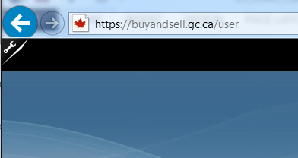

Select add content
Select Add content – the first item
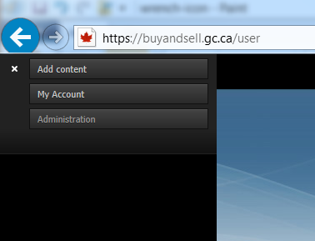

Select event
Select the Event content type
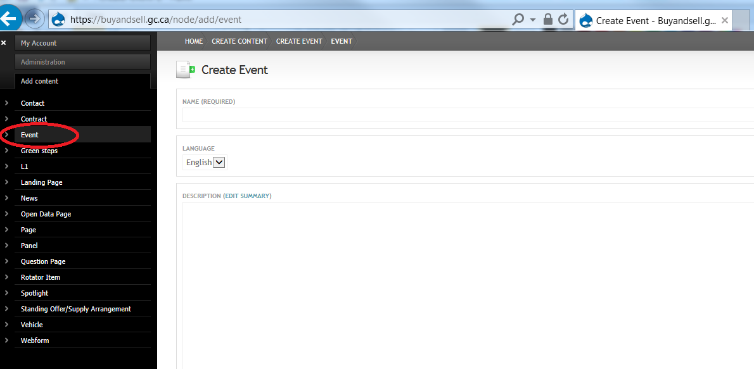

Fill out the text fields
Some text fields are mandatory* marked with an asterisk
Other fields are optional.

Name*
Enter the “name” (or title) of the event. Use sentence case capitalization: capitalize only the first letter of the first word and any proper nouns in your event “Name.” Do not use all capital letters (ALL CAPS).

Language*
This text field will default to the language choice (English/French) of your sign in site. (e.g. if you signed in to achatsetventes.gc.ca, the language field will default to “French”.) This text field does not refer to the language of the event.
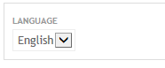

Description*
The description of your event should be simple. Include enough information to quickly inform users about the event and decide whether they want to register. Include things like what the event is about, who is putting on the event, and any contact information.

Do not duplicate
The Description field should not duplicate information that is found elsewhere in the event, (for example in the fields: “Location”, “City”, “Date”, “Time”, etc.)

Include hyperlinks
You can include hyperlinks that provide further information (for example, an external webpage). URLs should be anchored with a title for accessibility reasons. Please submit the text that you want hyperlinked, and the URL of the webpage, and we will create an anchored hyperlink within the text.
Example of an embedded link: For more information, see the Canadian Broadcasting Corporation.

Do not copy from Word (use a text editor)
Do not copy and paste from a Microsoft Word document.
Type your description directly into the Description field.
Alternatively, you can copy and paste a saved description from Word to a text editor (e.g. Notepad) first and then to the description field. A text editor will remove that will interfere with accessibility of the content.

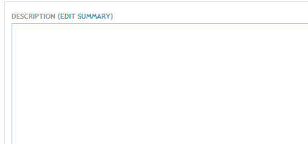

Date*
The “Date” text field displays when an event will start.
You can select Show end date box for multi-day events. Then you can enter the end date and time of the event.

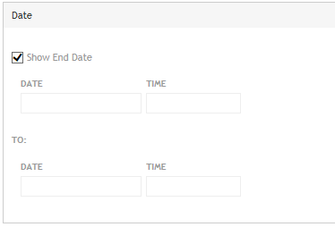

Timezone (optional)
Select the time zone of your event. There are options for daylight time and standard time zones.

Location*
Enter the location details of the event. You should include location information such as the name of the building, the floor number, the suite number, and the street address. If an event is available online, you can include this information in the location field.

Do not duplicate
Do not enter information about the city or the province/territory since “City” and “Province/Territory” have their own text fields.

City*
Enter the city where the event is taking place. For online events enter “webinar” or “videoconference.”

Coverage*
Select the province or territory of the event.

Do not just select Canada
Select all provinces and territories for a webinar. This ensures that users who filter by coverage will be able to view Canada-wide events. To make multiple selections, select ‘Ctrl’ key while also selecting provinces and territories.
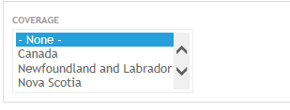

Audience*
Select the intended audiences for your event. Select all applicable options from the list. To make multiple selections, select ‘Ctrl’ key while also selecting audience types
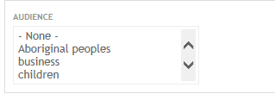

Status*
Select “Confirmed” when creating an event.
“Cancelled” is used for published events that will no longer occur.
We no longer use the options “N/A” or “Tentative”.
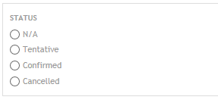

Subject*
Select the subject that is relevant to your event. The subject of the event will determine who reviews your event before it is published. (e.g. an automatic email is sent to OSME reviewers when “OSME” is selected as the subject. See sections 7. Event workflow and email notification process; and 8. The review process – changing the workflow.)

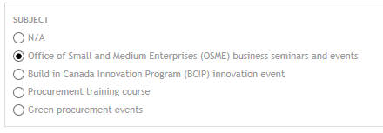

Event type*
Select all applicable options. To make multiple selections, select ‘Ctrl’ key while also selecting event types.
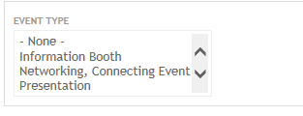

Registration (optional)
There is a registration title field and a registration URL field. Enter the text that you want to appear as a hyperlink in the registration title field. (e.g. “Online registration form.”) Enter the URL that you want users to open in the registration URL field. (e.g. https://buyandsell.gc.ca/forms/seminar-registration-form-atlantic-region.)

Used only for external registration service
The registration fields are only used to direct users to another webpage to register for the event. Any other registration information belongs in the description field. (e.g, “This seminar is free”, “Call Sally Smith to register: 1-819-956-0110.”)

When registration is closed
When the registration for a published event closes, you should remove the registration URL and enter “Full” in the registration title field.
You should also indicate that registration has closed by selecting “Full” in the Space Availability field (see below).

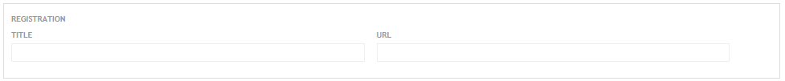

Organization*
Enter the name of the organization hosting the event.

Space availability*
On the drop-down list, select:
- Space available - when there is no restriction on space (e.g. an information booth), but monitor the event closely and “edit” the event and change the selection to “Full” when appropriate.
- n/a - when it is not applicable
- Contact organizers - when a group other than OSME is hosting the event and the space availability is unknown.
- Full - when an already published event becomes full. Do not select “Full” when creating a new event.

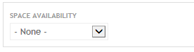

Event language*
Select the language of the event. This selection refers to the language used by the speaker(s)/presenter(s) at this event.
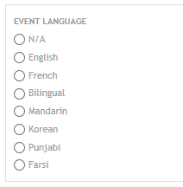

Region*
Select the region where the event is taking place. This information is useful for Event management purposes and is not visible to the general public when the event is published. (See Section 10. Event management page for more information.)

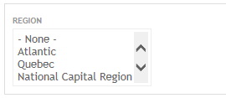

Groups Audience (obsolete)
This text field is no longer used. (Please ignore this field.)
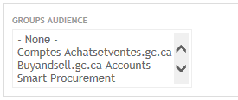

Groups Content Visibility*
Select “Public – accessible to all site users”.
The option “Private – Accessible to only group members” is no longer used.
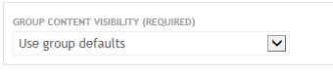

Add a comment

To include a comment about your draft, select Moderate, then select Revisions, then Compare revisions.

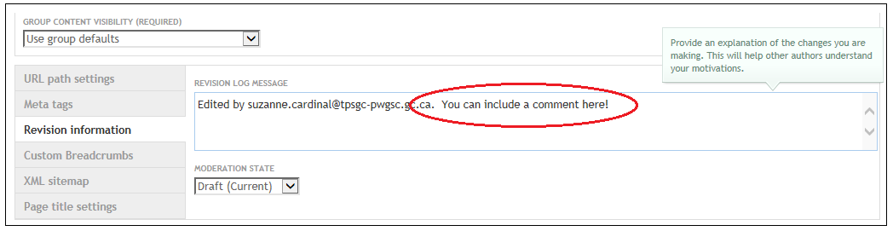

Save your event
Select “Save” to save a draft of your event. You must save all changes or you will lose your data.

Do not use Preview button
You should avoid using the Preview button since it does not save your changes.

Save at any time
You can save an event at any time. Each new save will create a new draft. You can review difference between draft by selecting the Moderate button.
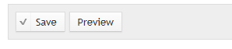

Translate the event
Once you have created and saved one language version of the event (e.g. English), you must now create the corresponding language version of the event (e.g. French).

Select Translate
Select Translate from the moderation buttons that are now displayed beneath the title of your saved draft.

Select Add Translation
Select “add translation”.
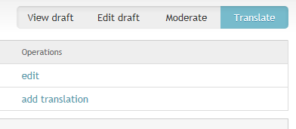

The page Créer Événement / Create Event will open.

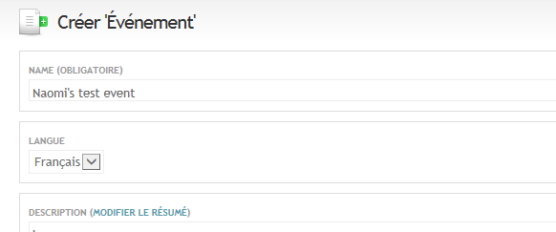

Replace fields with translated content
The content from your saved event will appear in the text fields. You must replace the content with your translation (e.g. replace the English content with the French equivalent) for all the following text fields:
- Name / Title
- Description / Description
- Emplacement / Location”)
- Ville / City

Drop downs are auto-translated
All of the other text fields (selection-based from drop-down arrows, or radial buttons) will automatically populate with French equivalents or the information that you entered in the English language version of the event.

Save Translation
Select “Sauvegarder” (“Save”) at the bottom of the page when you are finished entering the French content.

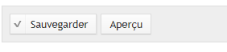

You have now created a complete draft (an English version and a French version) of an event.

Send for review
When both language versions of an event are ready, you must send your event for review. It won’t get published until it is reviewed.

Change a draft

When you are signed in, administrative buttons will always display on the save draft version of your event.

Select edit draft button

Select the Edit draft button.

Make changes
Make changes to your draft.

Save
Save the draft. This will create a new draft. You can repeat this process as many times as necessary.

Edit translation
Whenever you edit one language version of an event, be sure to edit the other language version of the event so that both event versions have equivalent information.

Change a published event

Once an event is published, the following buttons will always display on the English event, when you are signed in:

Sign in
Ensure that you are signed in.

Select new draft
From the published version of the event, select New draft from the moderation buttons.

Make changes
Make the required changes.

Save Changes

If you are ready to publish the changes, save the changes as Needs review (instead of as a draft) so that an automatic email is sent to the event reviewer. (See the section on Event workflow and email notification process for more details.)

Compare the differences between drafts

Select Moderate
Select Moderate to see your drafts. The most recent draft will be on top, and is coloured “pink.” (Previous drafts will appear in “white,” a published versions will appear in “green”.) For each draft you will see the name of the event administrator who created the draft, the creation date of the draft, the status of the draft (published, unpublished), and any revision comments.

Select Revisions > Compare Revisions > Select the versions
To compare the difference between drafts select Revisions, then Compare revisions, then select the radial button on two events to compare any two revisions, then select show diff. Suzanne - we need some screen shots here!

Send your event for review

When both language versions of an event are ready, you must send both language versions of the draft event to an event reviewer before it can be published.

The review process
An event is reviewed three times before it is published on Buyandsell.gc.ca.
- Event administrator creates an event.
- A designated reviewer reviews the event.
- The Buyandsell.gc.ca Team reviews the event, and publishes it on Buyandsell.gc.ca.

Automatic emails
Auto emails are triggered when the publication status of the event changes to ensure the event administrator, the reviewer and the Buyandsell.gc.ca team is aware of the status change and their required action.
When the status changes to:
- Needs review – the reviewer is emailed
- Ready to Publish – The buyandsell.gc.ca team is informed
- Draft – the event creator is emailed (in the event of required changes)

Save your event as needs review
You must save your event as Needs review.

Select Moderate
Select Moderate, then select Needs review, then select Apply.
Important: You must save both the English and the French versions of the event as Needs review.
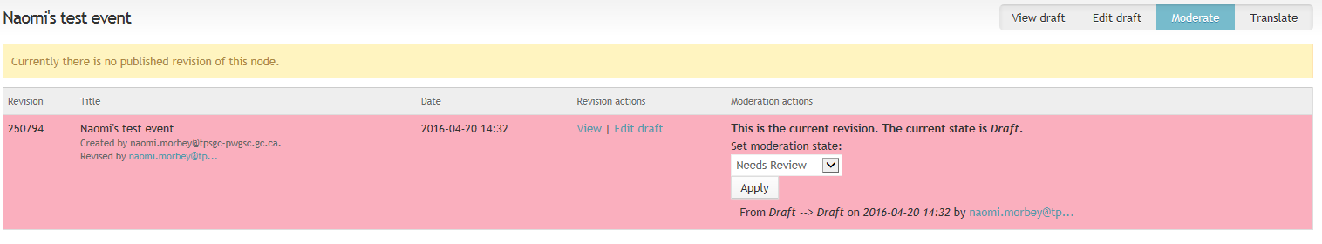

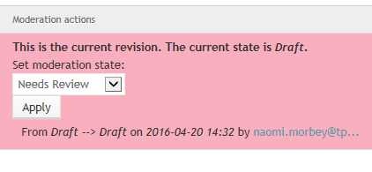

Event reviewer reviews the event
If the even reviewer is satisfied with both language versions of the event, save them each as Ready to publish. If the event reviewer discovers missing information they can send the event back to the event creator by saving the event as Draft.

The Buyandsell.gc.ca team reviews the event
|If we review the event and discover missing information, or require clarification, we will send the event back to the event creator by saving the event as Draft. We can also send the event back to the reviewer (instead of the event creator) by saving the event as Needs review.

View and sort all your events in a list

The “Event management” page contains a list of all of the events that were created. The list shows the status (published, not published) of the event. There are filtering and sorting options available.
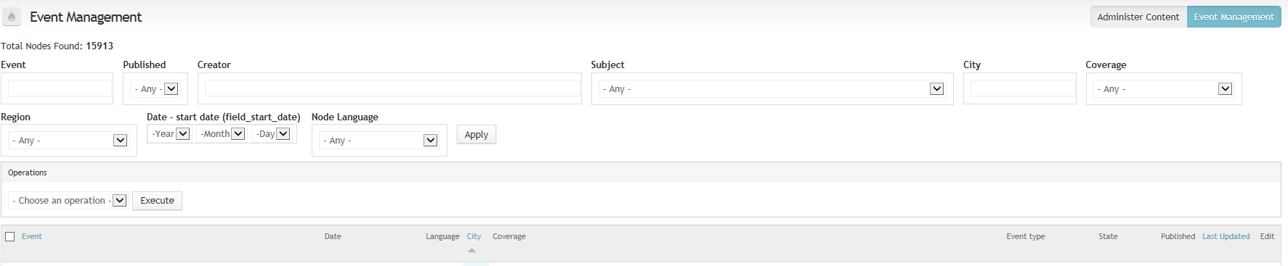

Access the events management page
Follow these steps to access the “Event management” page:

Sign in to Buyandsell.gc.ca
Sign in with your myKEY via Buyandsell.gc.ca/user

Select the wrench
Select the wrench icon to open the administration menu

Select Administration
Select “Administration”

Select BAS Administer Content
Select “BAS Administer Content”
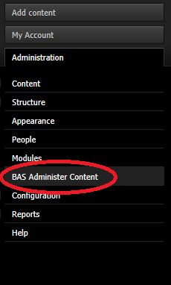

Select event management
Select “Event Management” (located in the top right-hand corner of the screen)
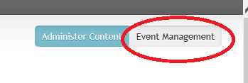

View and sort events

On the event management page, you can view and sort events.

Apply Filters
You can filter the events by
- current state (published, not published),
- the date of the last modification,
- the name of the creator of the event, etc.

To apply the filters, select your filtering option(s) and select “Apply.” The events that meet your filtered criteria will display.
If you do not initially find your event, decrease the number of filters that you set and select “Apply” again.

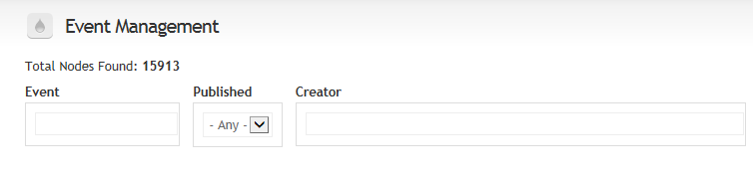

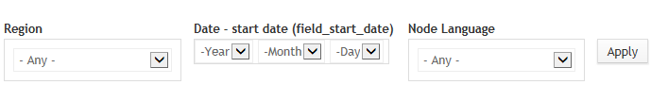

Pagination
The list of events is paginated; select a page number at the bottom of the page to view more events.

Sort by event, city or last updated
You can sort the list of events by selecting one of the following subtitles: “Event,” “City,” or “Last updated.” (These subtitles display in blue).

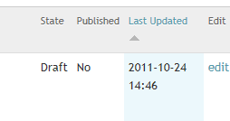

Select a subtitle to sort the column in ascending order. Select the arrow next to the list to change the sorted list to descending order.

Get more information and support

Contact us via email at: achatsetventes.gc.ca@tpsgc-pwgsc.gc.ca for any of the following:
- creating a new event administrator account;
- removing an event administrator account;
- help/questions when creating an event
- help/questions when reviewing an event; and
- feedback about events.

